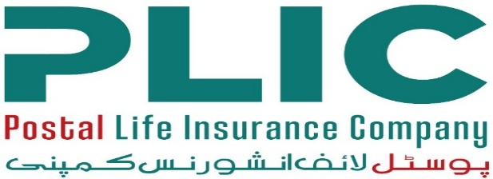

CAREER OPPORTUNITIES

Postal Life Insurance Company Limited (PLICL), established under the Insurance Ordinance, 2000, is one of Pakistan’s oldest and most trusted life insurance providers. As a state-owned entity, PLICL has a long-standing reputation for financial stability, customer-centric services and nationwide accessibility. The Company operates through an extensive network ensuring quality life insurance products to the individuals and families across both urban and rural areas of the country. The Company continues to modernize its operations through digital transformation, improved customer service standards, and strengthened compliance with regulatory requirements set by the Securities and Exchange Commission of Pakistan (SECP).

PLICL is inviting applications from dynamic, qualified, and results-driven professionals for the following position: -
Sl. No. | Position Title | No. of Posts | Maximum Age | Minimum Qualification Requirements | Minimum Experience  Requirements | Location
1. | Company Secretary | 1 | 55 years | Should be a member of a recognized body of professional accountants OR Fellow or Associate member of the Casualty Actuarial Society or the Institute of Actuaries in England or Society of Actuaries in the USA. | Minimum 5 years of post-qualification experience, preferably in an Insurance Company. | Islamabad

- Candidates who meet the above criteria may apply online through our website at www.plic.com.pk/careers.
- The last date for submission of applications is 26th June 2026.
- Applications submitted through post or by hand will not be accepted.
PLICL is an Equal Opportunity Employer. We strongly encourage female candidates to apply.
(-sd-)
Human Resources Department
Postal Life Insurance Company Limited,
051-9192991

